**Experiment number:**  2

**Title: Application of Diode as Rectifiers.**

**Group Leader: Aminul Islam (19-39571-1)**

**Group members:**

**1. MD Saiful Islam (18-36363-1)**

**2. Aminul Islam (19-39571-1)**

**3. Rhisul Islam (19-41018-2)**

**4. SHAON, INDROJIT DHE (18-38674-3)**

**5. Md sakib hossain zisan (18-37823-2)**

**Abstract:**

A diode rectifies an ac voltage, so that it can be smoothed and converted into a dc voltage. A rectifier, however, can produce a constant or variable DC voltage. A diode rectifier can produce a fixed DC voltage whereas an SCR can produce a variable DC voltage.

**Introduction:**

The objectives of this lab are to:

1. study Half wave rectifiers,
2. study Full wave rectifiers.

**Theory and Methodology:**

Diode rectifiers are of the following types:

1. Half-wave rectifier.
2. Full-wave bridge rectifier.
3. Center tapped Full-wave rectifier.

A rectifier, however, cannot produce a smooth DC voltage. So the rectification block that makes the output DC voltage a smooth one follows a filter circuit. In this case, the capacitor acts as a smoothing filter so that the output is nearly a dc voltage. A filtering is not perfect; there will be a remaining voltage fluctuation known as ripple, on the output voltage.

The half-wave voltage signal is normally established by a network with a single diode has an average or equivalent DC voltage level equal to 31.8% of the peak voltage, whereas the full-wave rectified signal has twice the average or DC level of the half-wave signal, or 63.6% of the peak value.

## **Working of Half wave rectifier:**

The [half-wave rectifier](https://byjus.com/physics/half-wave-rectifier/) has both positive and negative cycles. During the positive half of the input, the current will flow from positive to negative which will generate only a positive half cycle of the a.c supply. When a.c supply is applied to the transformer, the voltage will be decreasing at the secondary winding of the diode. All the variations in the a.c supply will reduce, and we will get the pulsating d.c voltage to the load resistor.

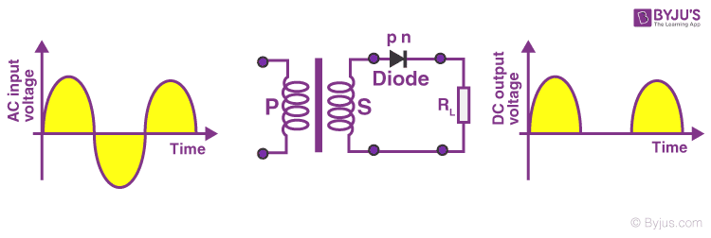

## **Working of Full wave rectifier:**

The [full-wave rectifier](https://byjus.com/physics/full-wave-rectifier/) utilizes both halves of each a.c input. When the [p-n junction](https://byjus.com/physics/p-n-junction/) is forward biased, the diode offers low resistance and when it is reversing biased it gives high resistance. The circuit is designed in such a manner that in the first half cycle if the diode is forward biased then in the second half cycle it is reverse biased and so on.

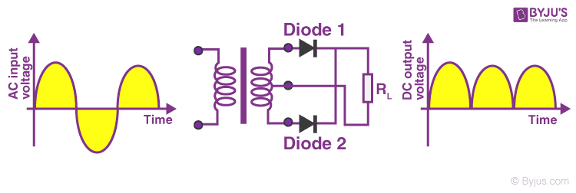

**Working Principle of Center Trapped Full-Wave rectifier:**

The center tapped full wave rectifier uses a center tapped transformer to convert the input AC voltage into output DC voltage. When input AC voltage is applied, the secondary winding of the center tapped transformer divides this input AC voltage into two parts: positive and negative

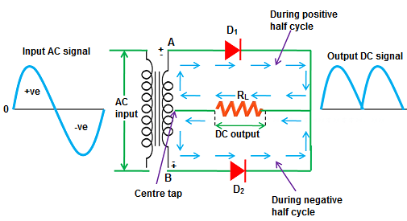

**Apparatus:**

1.Diode

2.Resistor

3.Dc Voltage

4.Oscilloscope

5.Function Generator

6.Transformer

**Result and Simulation:**

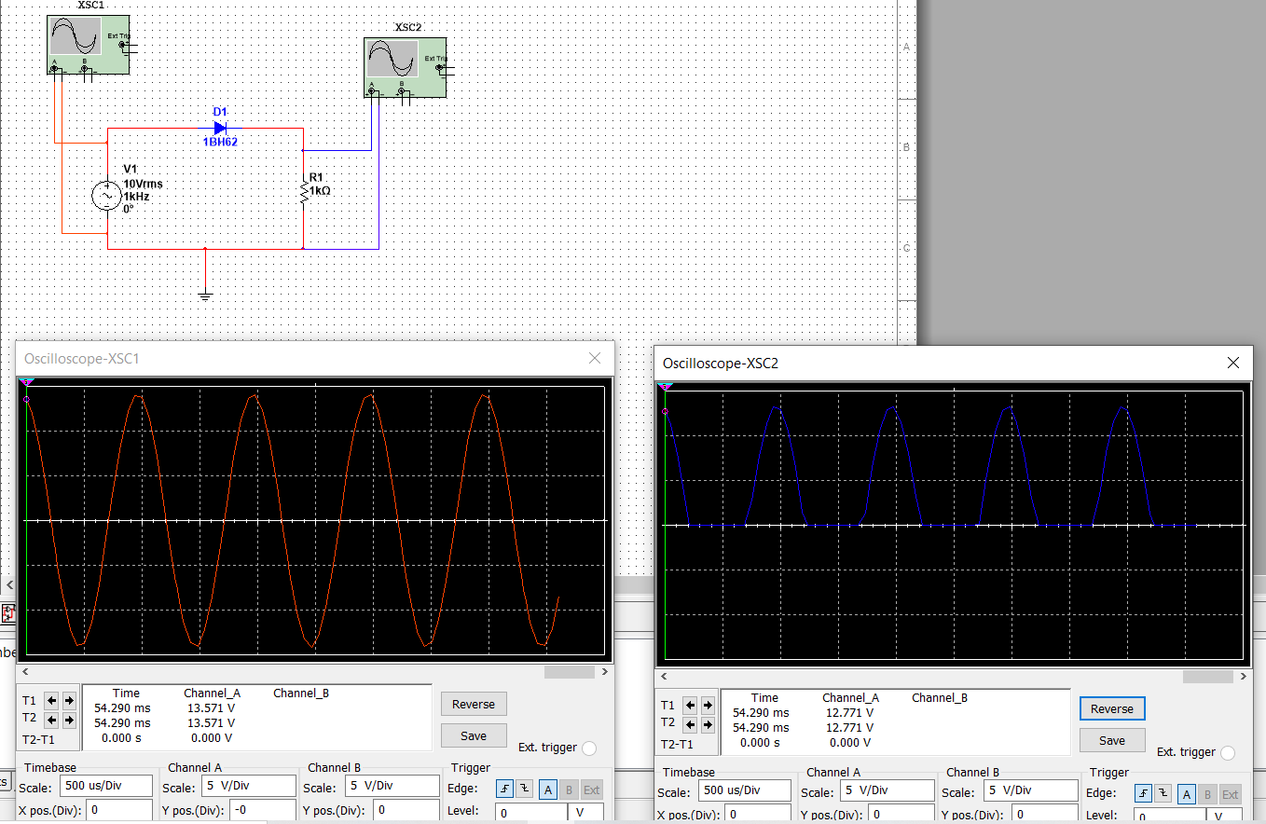

Fig 1: Half Wave Rectifier using one Diode.

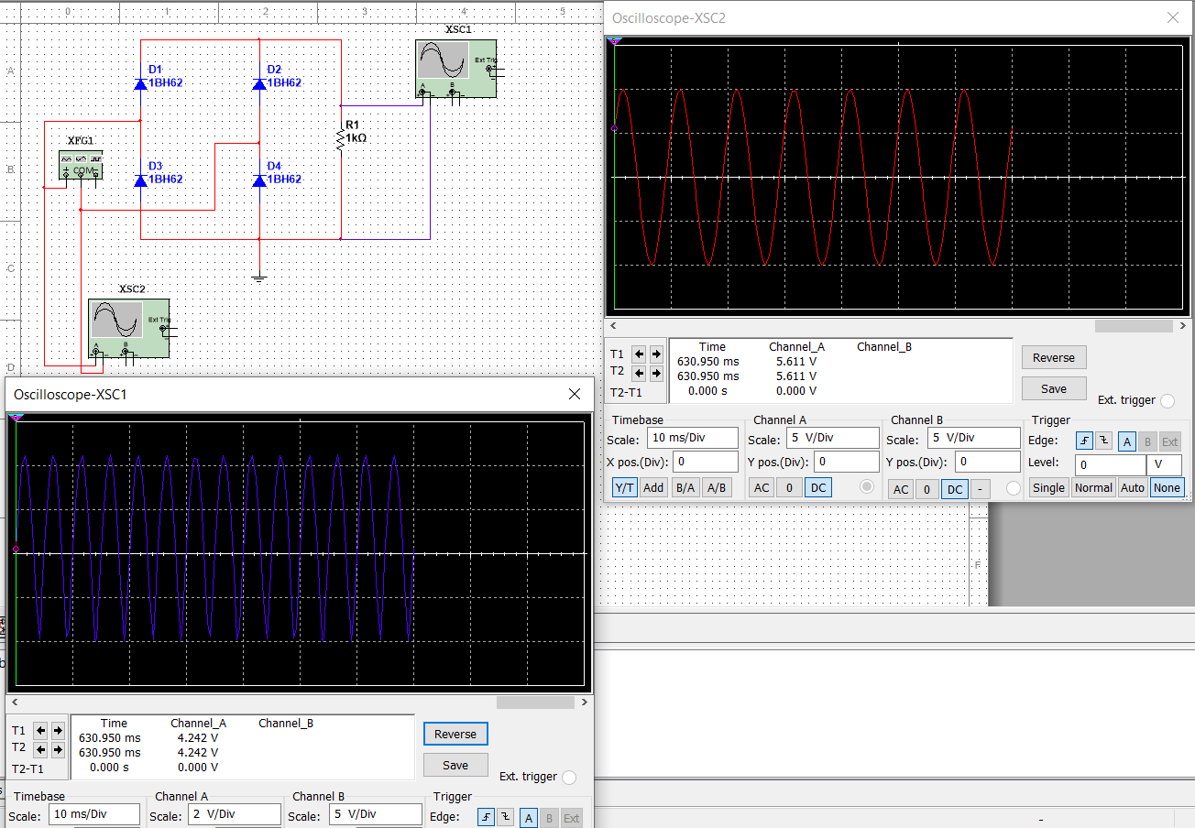

Fig 2: Full Wave Rectifier Using Four Diode.

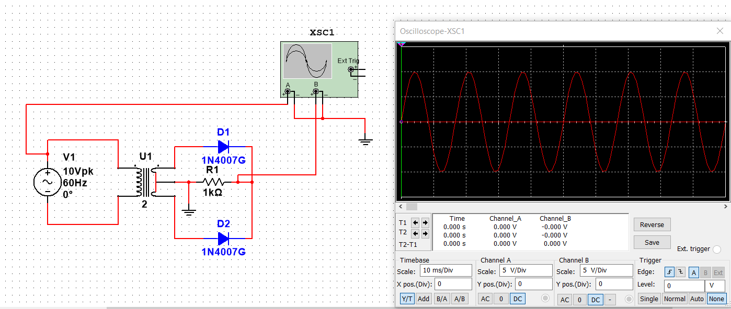

Fig 2: Full Wave Rectifier Using Two Diode.

**Discussions:**

The use of a half-wave rectifier can help us achieve the desired dc voltage by using a step-down or step-up transformers. Full-wave rectifiers are even used for powering up the motor and led, which works on DC voltage.